**Check Point 1**

**int led = 13;**

**void setup() {**

**pinMode(led, OUTPUT);**

**}**

**void loop() {**

**digitalWrite(led, HIGH);**

**delay(1000); // Wait for 1000 millisecond(s)**

**digitalWrite(led, LOW);**

**delay(1000); // Wait for 1000 millisecond(s)**

**}**

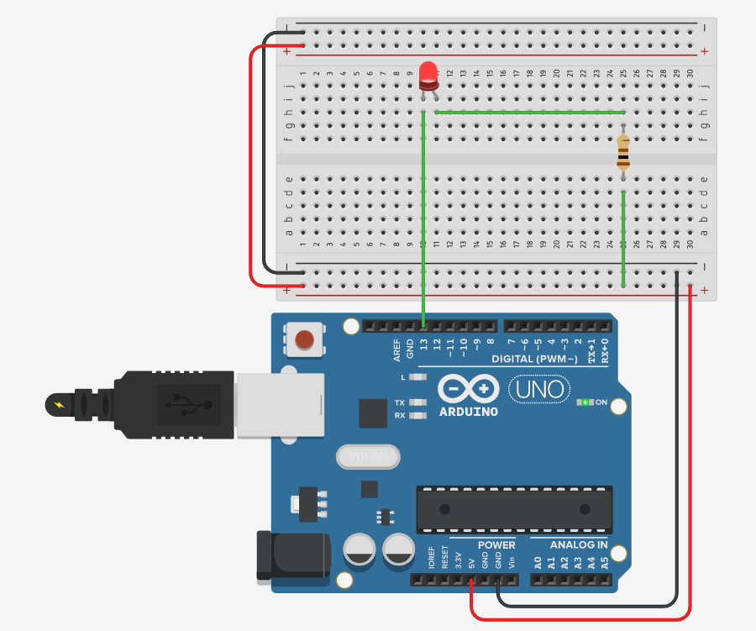

**Check Point 2**

**int led = 13;**

**void setup() {**

**pinMode(led, OUTPUT);**

**}**

**void loop() {**

**for(int i=0;i<3;i++) {**

**digitalWrite(led, HIGH);**

**delay(100);**

**digitalWrite(led, LOW);**

**delay(100);**

**}**

**for(int j=0;j<3;j++) {**

**digitalWrite(led, HIGH);**

**delay(300);**

**digitalWrite(led, LOW);**

**delay(100);**

**}**

**for(int k=0;k<3;k++) {**

**digitalWrite(led, HIGH);**

**delay(100);**

**digitalWrite(led, LOW);**

**delay(100);**

**}**

**delay(300);**

**}**